Software Design Description v 1.0
Kamil Moralewski
CEIS400— Team 4
Date: 2024/02/03

Contents
1. Software Design Description 4
1.1 Introduction 4
1.2 System Overview 4
1.3 System Architecture 4
1.4 Data Dictionary 5
1.5 Component Design 6
1.6 Human Interface Design 11
1.7 Requirement Matrix 11
1.8 Appendices 11
2. Revisions 13

Software Design Description

Introduction
Our purpose is to improve the checkout process for equipment at both warehouses to ensure there are no extra costs or losses. The problem we are facing is an inefficient equipment checkout system that is leading to losses for the company. The one in place now is a manual system that has led to theft and lost tools. Employees are bypassing the correct way to checkout equipment by going to the smaller warehouse that is closer rather than the larger warehouse.

The aim of this software is to implement an automated equipment checkout system and a warehousing system. These systems will be integrated into the day-to-day operations of the maintenance department. The automated equipment checkout system will allow maintenance personnel to efficiently check out and return tools, reducing losses and enhancing accountability. The enhanced warehousing system aims to centralize inventory management and minimize excessive inventory.

References:
- Software Architecture Description Document
- Business Problem Scenario
- Requirements Specification Document (IEEE 830)

System Overview
The system is built for 3 different user types:
- Administrator
- Warehouse Employee
- Maintenance Employee

Each user has access to certain features based on their privileges. Refer to 1.5 Component Design for descriptions on each feature.

System Architecture
Supported Architectural Styles:
- Object-Oriented: Each class will include objects that will interact with one another to handle different data and behaviors.
- Layered: All modules will have their place in the organized structure to make maintenance easier.

Supported Quality Attributes:

- Efficiency: Supported by using resources wisely and maximizing power without increasing expenses.
- Maintainability: Supported through ongoing update and maintenance to all components of the system.
- Performance: Supported through the methods used to handle and organize data following SRS.
- Reliability: Supported by keeping things organized and making sure each part of the system is functioning properly.
- Scalability: Supported by adding new features or datasets to grow the system.
- Security: Supported through the methods used to protect and control access to the system and its sensitive components.
- Supportability: Supported by having a support team to help with troubleshooting and support.
- Usability: Supported through the implementation of a user-friendly interface that users will enjoy.

Data Dictionary
User: Class representing all users.
- Attributes: UserID, Username, Password, Role
- Methods: Login(), Logout(), CheckOut(), CheckIn(), CreateAcc(), RemoveAcc(), UpdateAcc(), ShowAcc()
Warehouse: Class representing each warehouse.
- Attributes: WarehouseID, WarehouseName, Location
Inventory: Class representing entire inventory in both warehouses.
- Attributes: WarehouseID, ToolID, ToolName, Quantity, Availability, CheckedOutByUserID
- Methods: ShowInv(), UpdateInv()

Component Design
Static View:

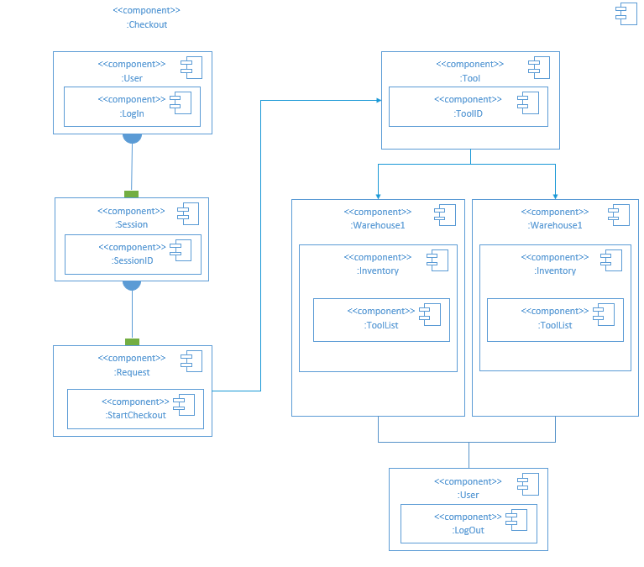
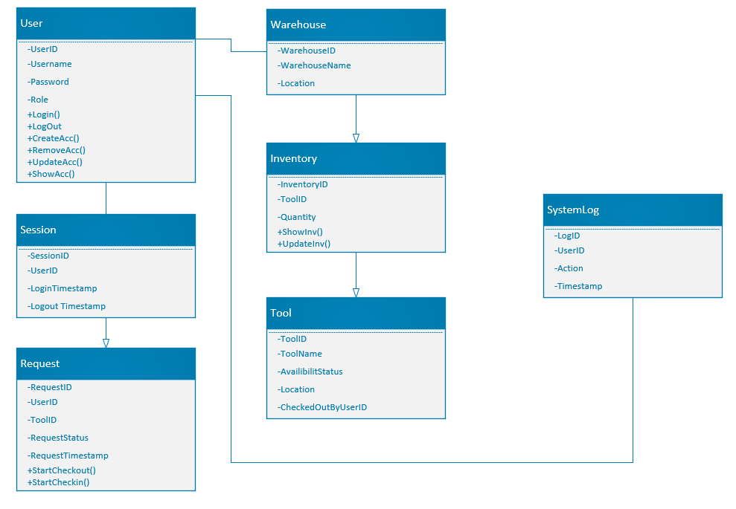
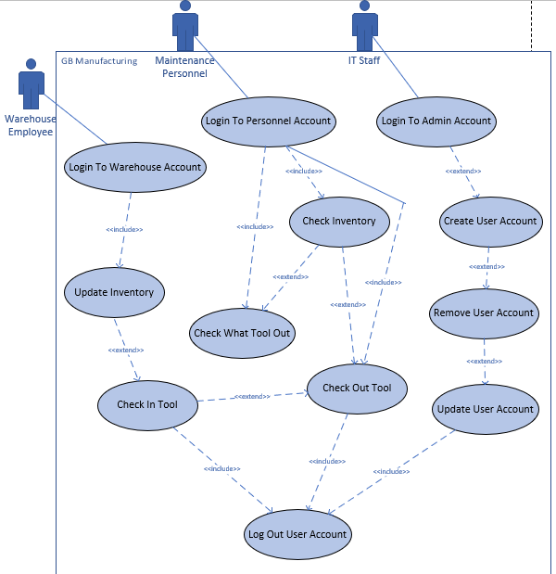

Dynamic View:

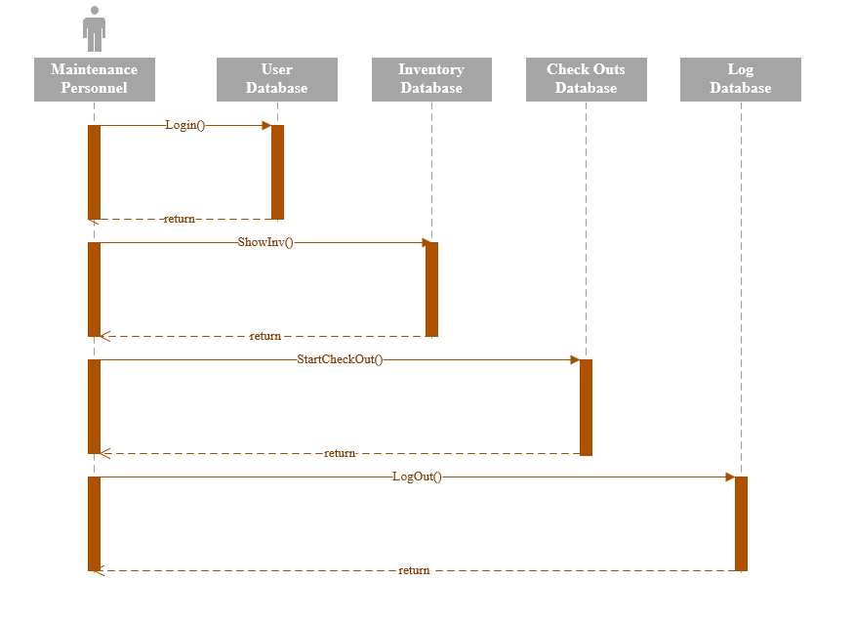
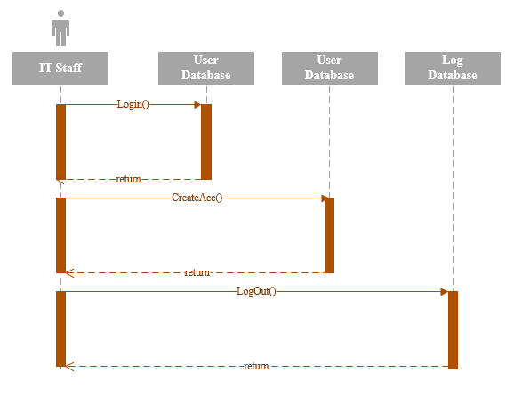
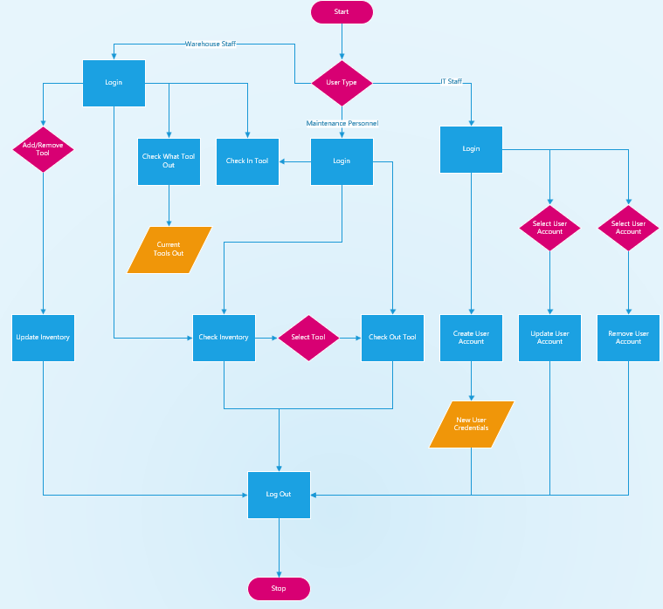

Human Interface Design
- Users will be presented with a login screen where they will enter their credentials.
- If credentials pass, they will be presented with the main menu screen which shows all available features and will only let the user click the ones they have access to.
- Each button is access to the listed feature and will bring the user into a new window with the information they need.
- After performing their intended task, they will click logout and exit the application.
- Every session and tool request will be added to the system log during the logout process.

Requirements Matrix
Pass:
- All test cases functional
- Both warehouses in sync with inventory
- Spelling and punctuation
- Follows dependencies
- Stays under budget

Fail:
- Two test cases fail
- Both warehouses having a different inventory count
- User authentication issues
- Hardware overload

Appendices
None

Revisions

Date | Revision | Description | Author
02/03/2024 | 1.0 | Created Software Design Description | Kamil Moralewski

